Name Date
Stage 9 End of unit 10 test
1 Marcus has some $5 and $10 notes. He has a total of $120.
a Show that he could have eight $5 notes and eight $10 notes.
[1]
b Marcus has f $5 notes and t $10 notes. Write down an equation to show that
he has a total of $120.
[1]
c Marcus has six $5 notes. Work out the number of $10 notes he has.
[1]
d Show that Marcus cannot have exactly 7 $5 notes.
[1]
2 Here is an equation:
a Complete this table of values.
x | 0 | 2 | 4 | 6 | 8 | 10
y
[2]
b Draw a graph of
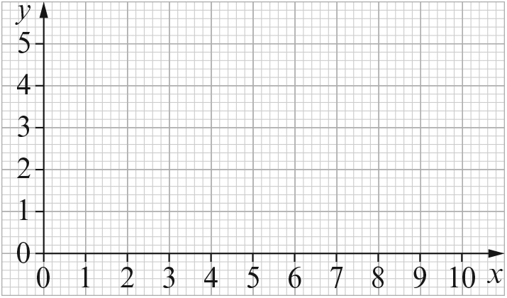 [2]
c Rearrange the equation in the form y = …
[1]

d Work out the gradient of the line.
[1]
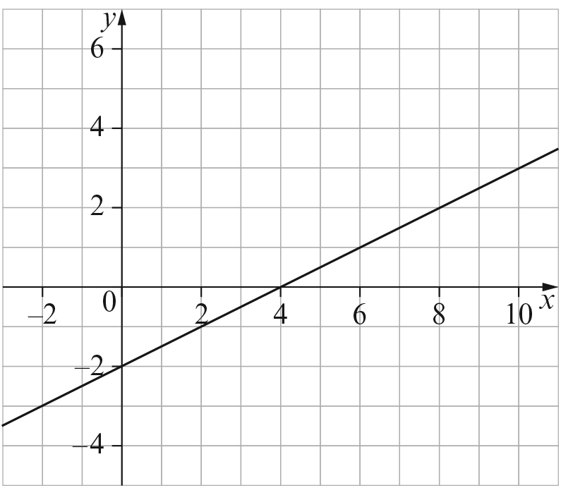
3

a Work out the gradient of this graph.
[1]
b Work out the y-intercept.
[1]
c What is the equation of the graph?
[1]
d Is (44, 20) on the line? Give a reason for your answer.
[1]
4 Here is an equation: .
a Show that this is the equation of a straight line with a gradient of .
[1]
b Work out the y-intercept.
[1]

5 You can exchange 50 dollars for 600 reals.
a Draw a graph to show the exchange rate. Show dollars on the x-axis.
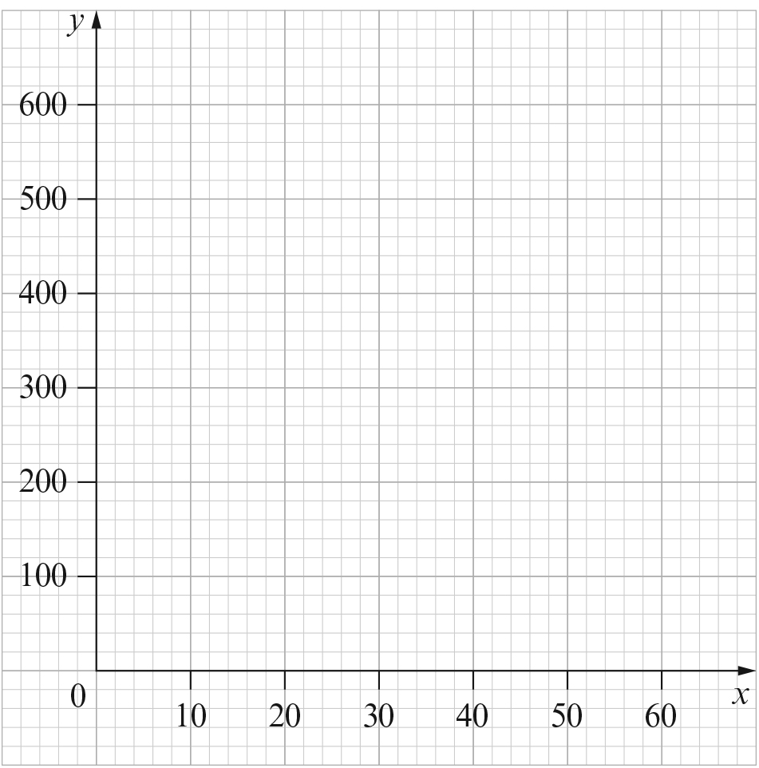 [2]
b You can exchange x dollars for y reals. Write down the equation of your graph.
[1]
c Sofia exchanges some dollars. She receives 1560 reals.
How many dollars does she exchange?
[1]
[Total: 20 marks]

END OF TEST

